

**JACKET ORDER FORM**

**\*\*Order Deadline June 30th, 2023\*\***

**Price: €50**

**\*\*Please choose from a wider fit or narrow fit jacket. If you require smaller than these regular sizes please choose age 11-12 or 13-14\*\***

**Result Jacket RS230M (Wider fit)(measurements in cms)**

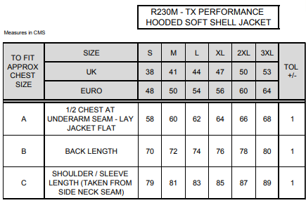

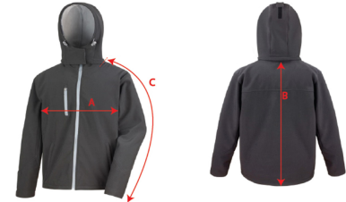

**Result Jacket RS230F (Narrower fit)(measurements in cms)**

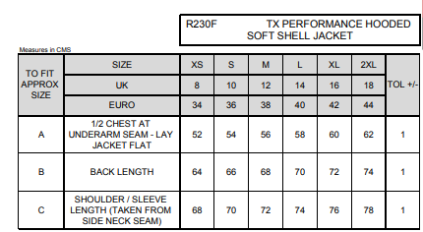

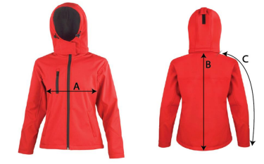

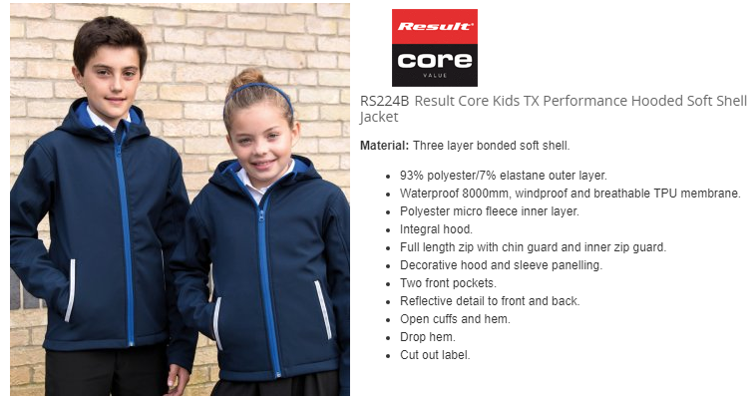

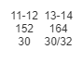

|  |
| --- |
| **PAYMENT IN FULL REQUIRED ON PLACING ORDER** |

|  |  |  |
| --- | --- | --- |
|  | **SIZE & CODE** | **QUANTITY** |
| **JACKET** |  |  |

**PUPIL’S NAME:**

**SCHOOL: SCARIFF COMMUNITY COLLEGE.**

**PARENT/GUARDIAN CONTACT NUMBER:**

Please complete form and either post it to Address on this sheet or email to

carmel@allseasonssport.ie. Payment either by cheque/cash/postal order or banking online.

Please do not hesitate to contact me to discuss sizing spec or any other query.

|  |  |
| --- | --- |
| **IBAN Number:** | **IE65BOFI90418155771101** |
| **BIC Number:** | **BOFIIE2D** |

***Delivery of the jackets will be in September when the school reopens.***