28/10/2026
Dear Parent/Legal Guardian,
This year, all children aged 2‐17 years of age will be offered the Influenza (Flu) vaccine free of charge. Flu circulates in the community during flu season, normally from the beginning of October through to the end of April, and children are more likely than adults to get severe complications of flu. Children who are sick with flu may miss days in crèche, childcare or school and may miss out on their usual activities, such as hobbies and sports.
As well as helping to protect your child from serious complications if they get Flu, the Flu vaccine reduces the spread of Flu virus to other people, meaning that siblings, parents and grandparents of vaccinated children may also have increased protection from Flu.
The flu vaccine is recommended for all children aged 2‐17 years. The vaccine that your child is being offered is called Fluenz. It is a safe and effective vaccine that is given as a nasal spray.
All children can get the nasal flu vaccine by visiting their GP or local Pharmacist however, this year we have partnered with your child’s school to provide a convenient opportunity for your child to receive the vaccine.
Getting the flu vaccine will protect your child against infection with flu which can sometimes cause complications in children. Complications of flu in children include:
- • Pneumonia
- • Bronchitis
- • Rarely inflammation of the brain (encephalitis)
Vaccinating your child benefits them and also benefits their community as children can spread flu to those around them including those who may be older or have underlying medical conditions.
You can find further information at www.hse.ie/flu or you can speak to us here in the pharmacy.
If your child has already received a flu vaccine since September this year or has an appointment already arranged, please do not consent for your child to receive a flu vaccine in this extra clinic.
There will be a small number of children not able to have the nasal spray flu vaccine because of pre‐existing medical conditions or treatments. They will be identified by the information provided by you on the consent form. If your child falls into this category, they should still be vaccinated against flu with an injected vaccine, unless this vaccine is also not recommended for your child. They should attend their GP or Pharmacist to receive their flu vaccine, you will need to contact your GP or Pharmacist and make an appointment to arrange this.
Yours sincerely
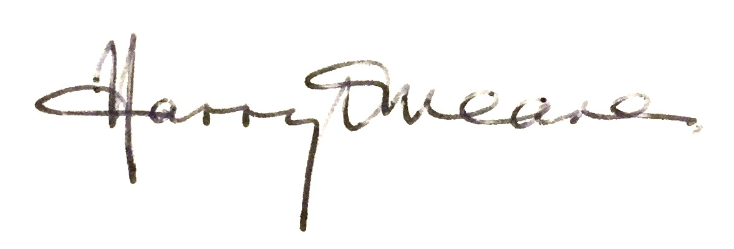
Harry O’Meara MPSI

